CSA0315 – DATA STRCTURE CO3 – AT2 (TREE TRAVERSAL VISUALIZATION) VISUALIZE TREE TRAVERSAL

Faculty: By:
Dr. T. Rajesh Kumar G.Manish(192210591)

1.Quick Sort
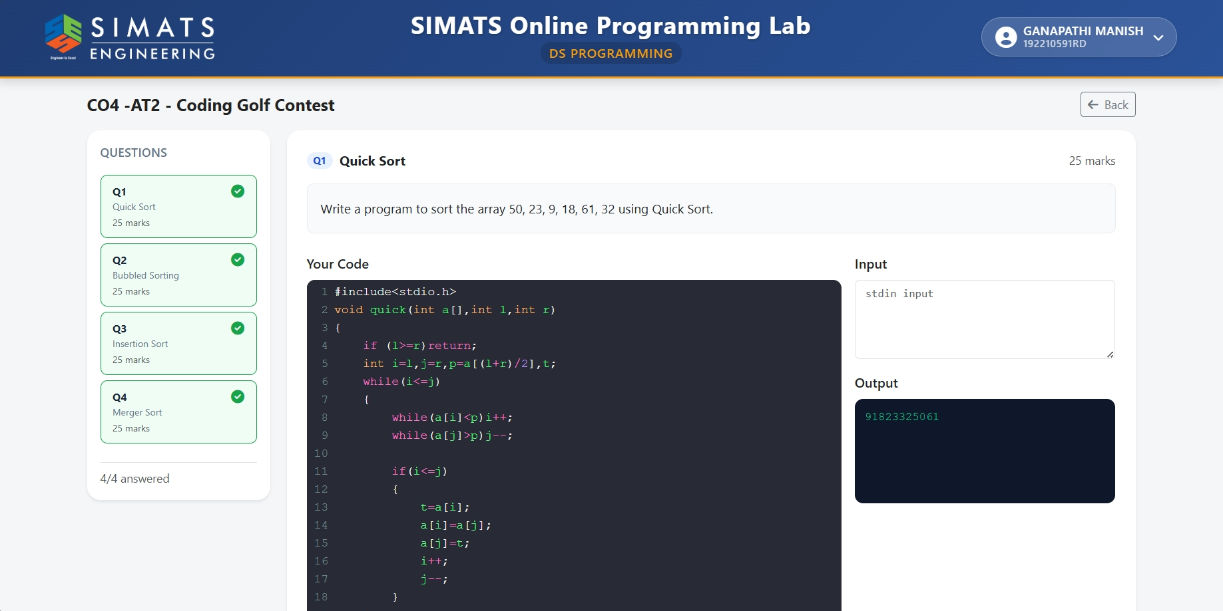

2.Bubble sorting
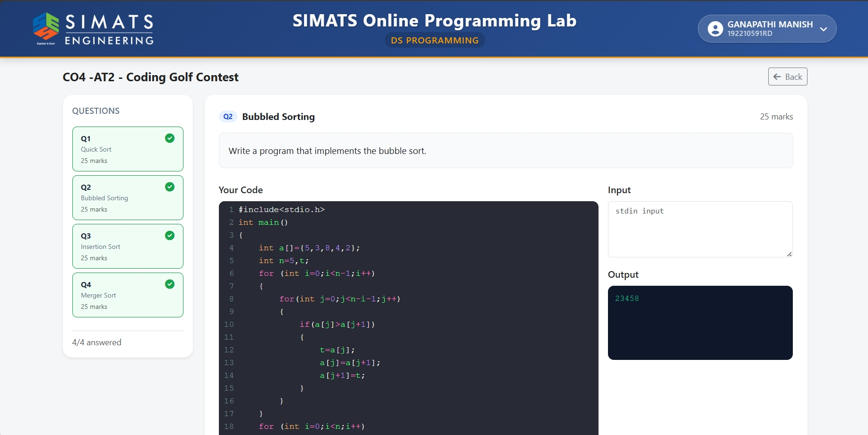

3.Insertion Sort
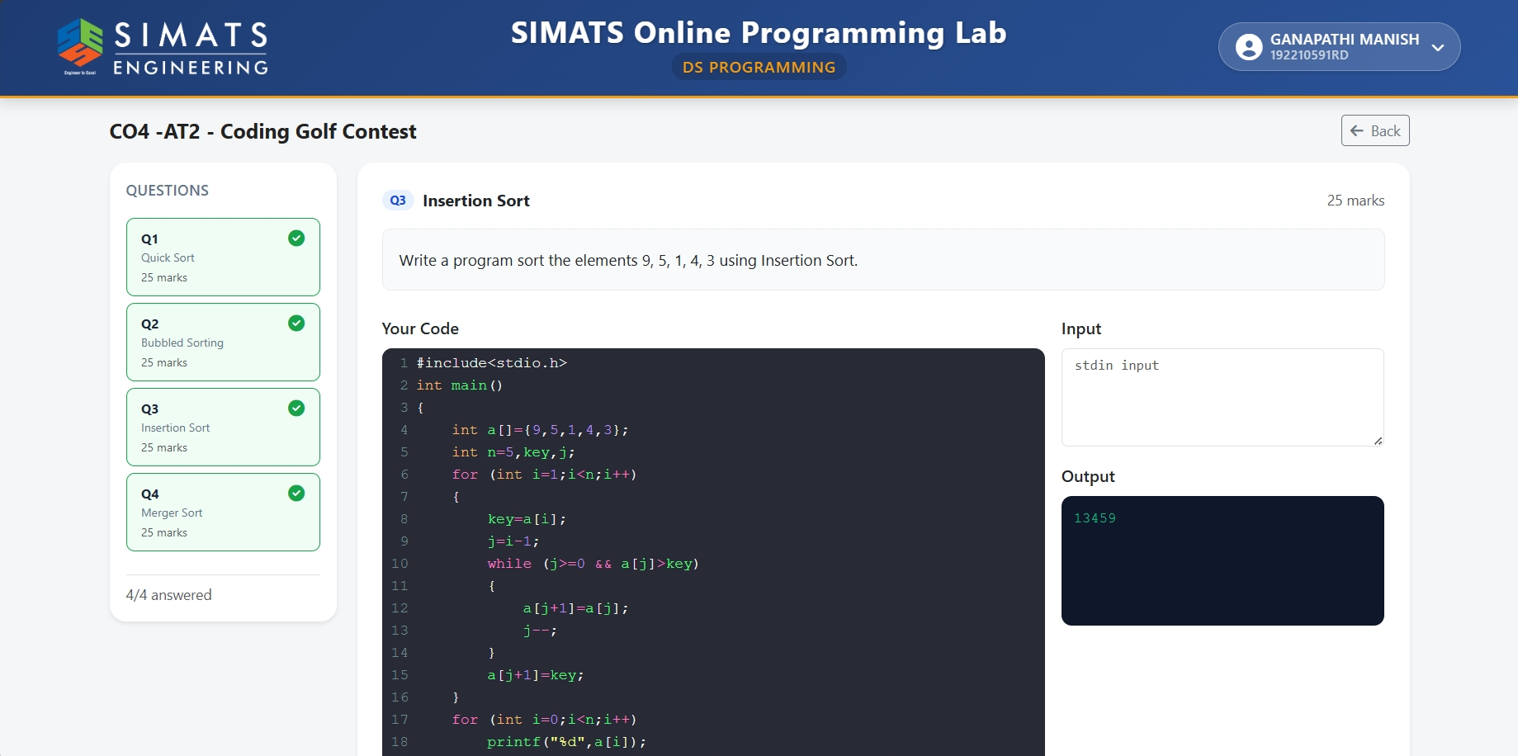

4.Merge Sort
